Create a new ASP.NET Core MVC Project using Entity Framework. Show with each step along with screenshot.

Add Necessary Nuget Packages

The necessary packages are:

* **Microsoft.EntityFrameworkCore.SqlServer**

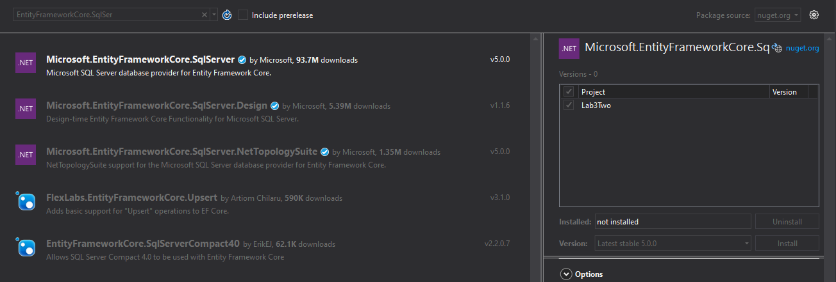

* **Microsoft.EntityFrameworkCore.Tools**

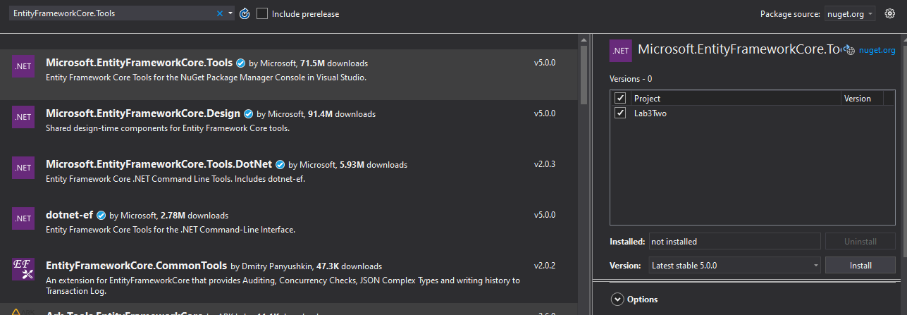

* **Microsoft.VisualStudio.Web.CodeGeneration**

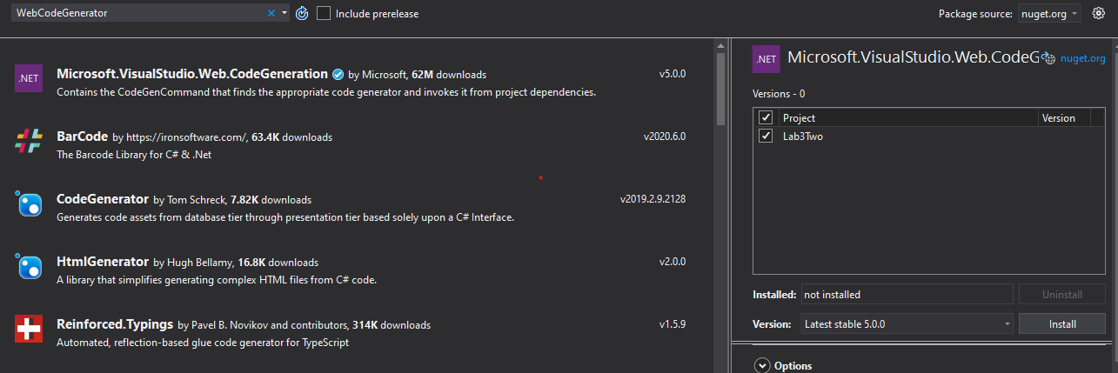

Create Model Class

The model class “**Movie**” created is:

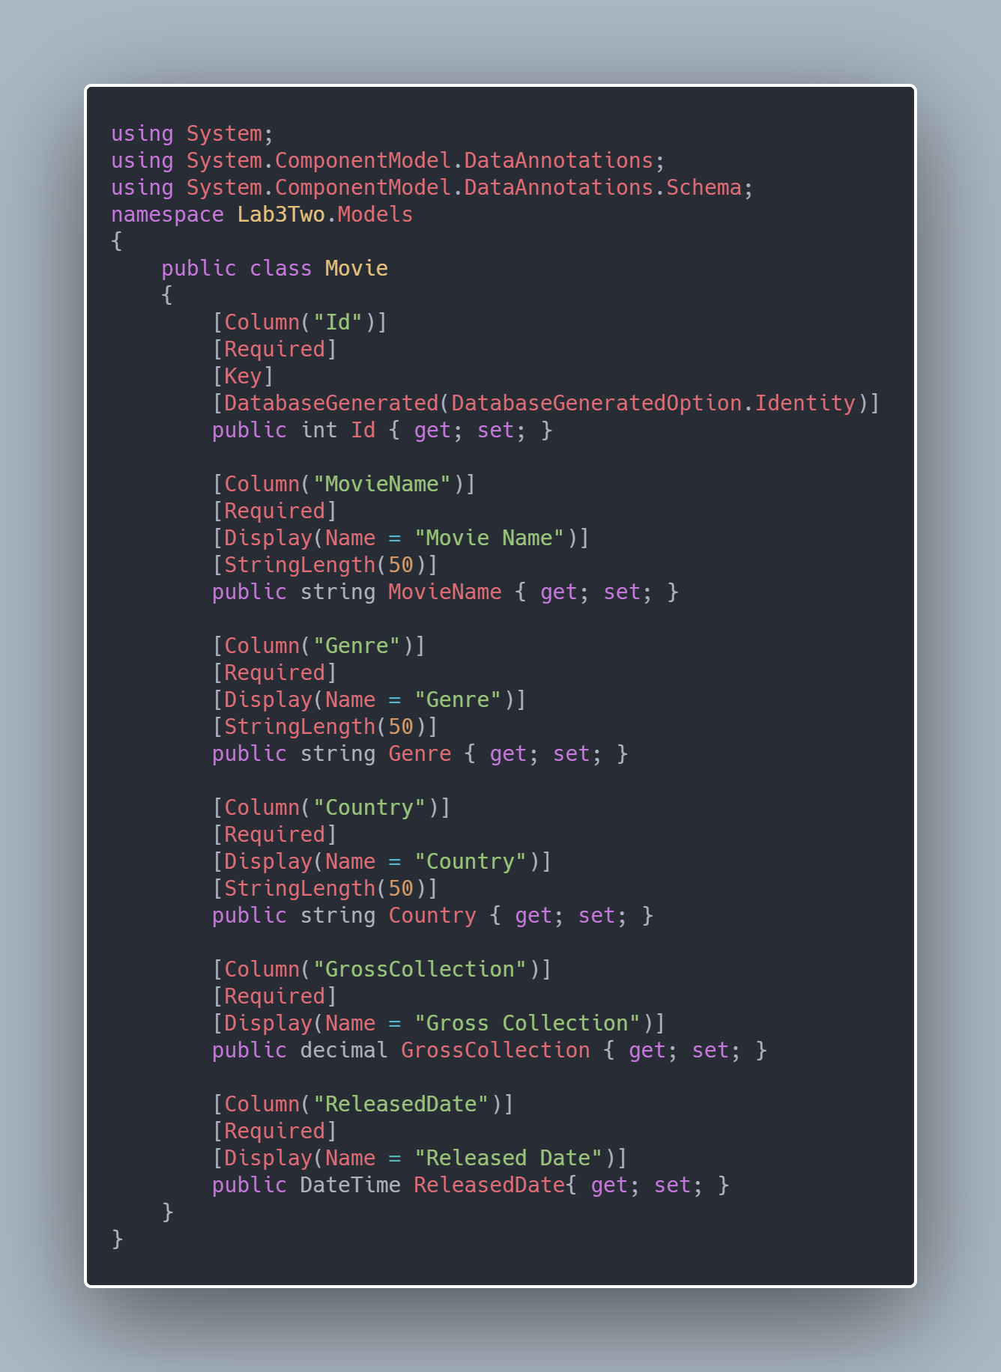

Also, “AppDbContext.cs” is created in same Model folder as:

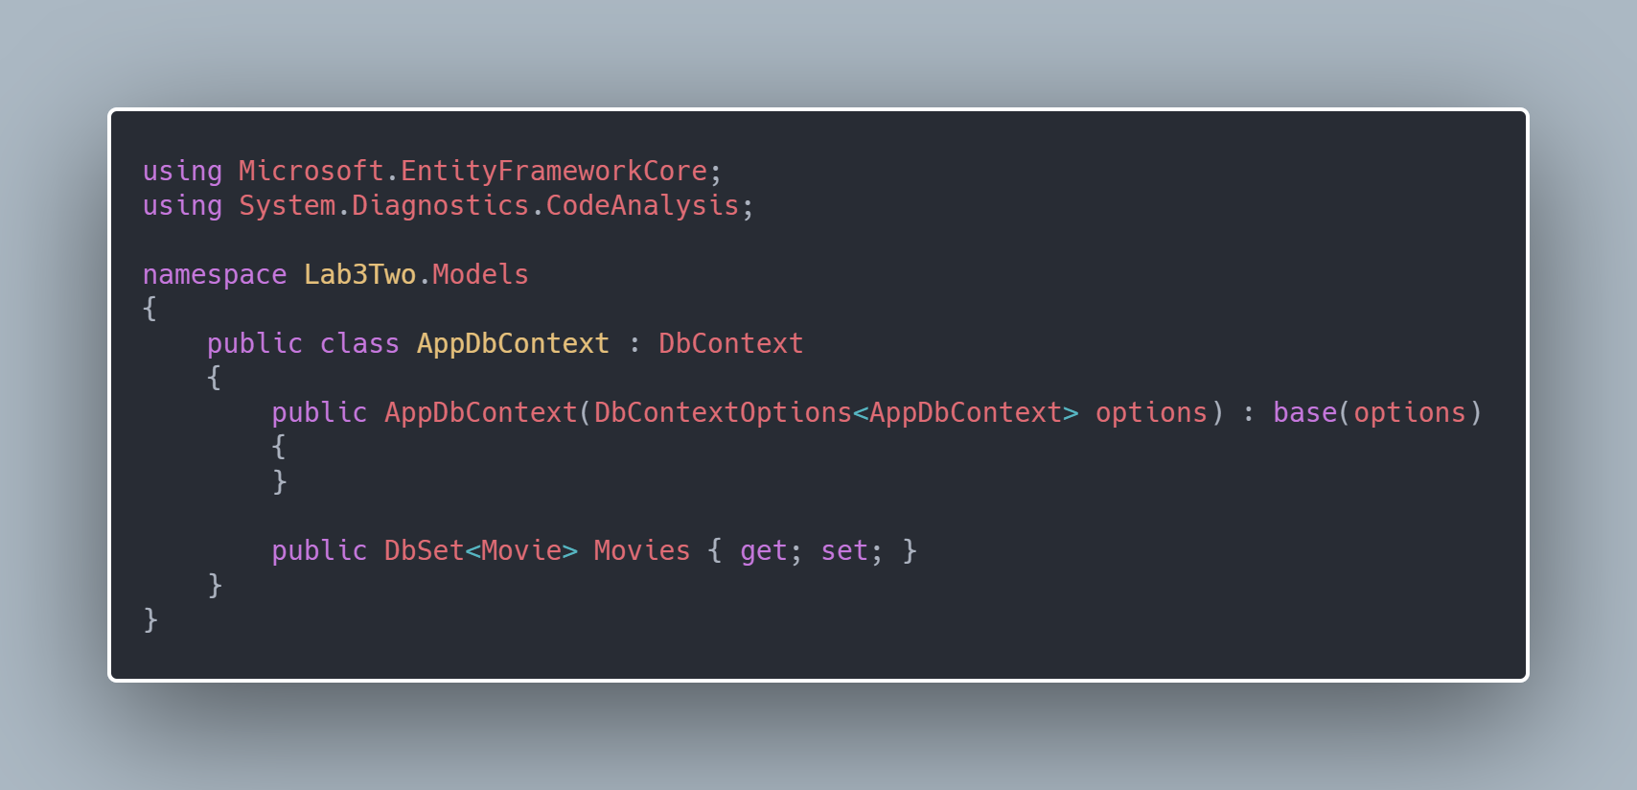

In startup.cs file the code for services is added as:

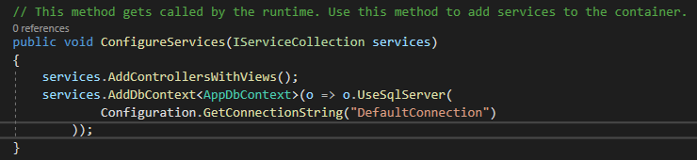



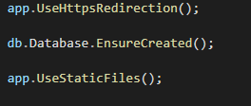

In appsettings.json file, connection string is added as:

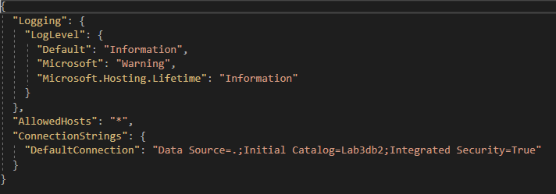

Generate Database and Table

The query to create database:

CREATE database Lab3db2

The table is auto generated after creating the controller as shown in figure below:

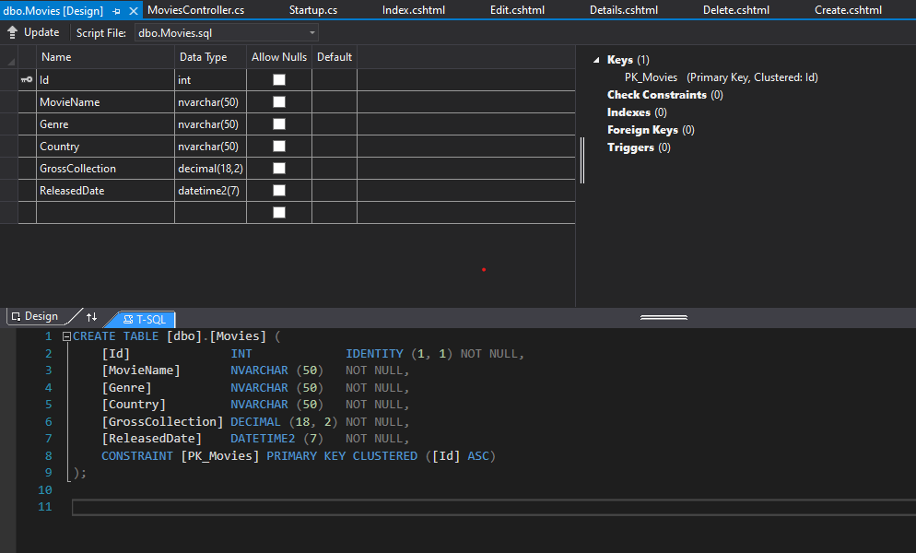

Create Controller and views using Entity Framework

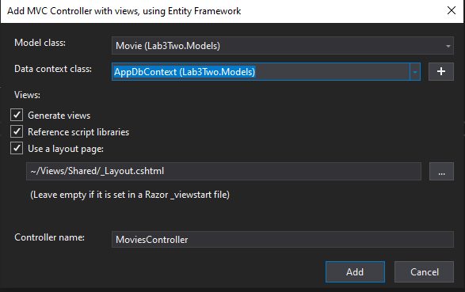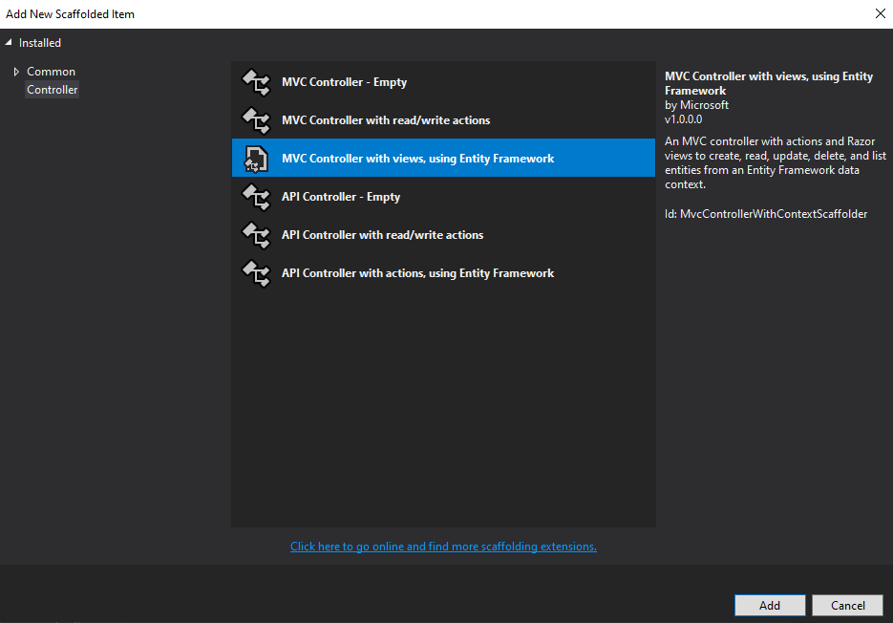The controller was generated after the processes as:

Explain your code in Controller and views

The views generated in **Views/Movies** are **Index.cshtml**, **Create.cshtml**, **Edit.cshtml**, **Details.cshtml**, **Delete.cshtml**.

* A constructor is generated with field member as:

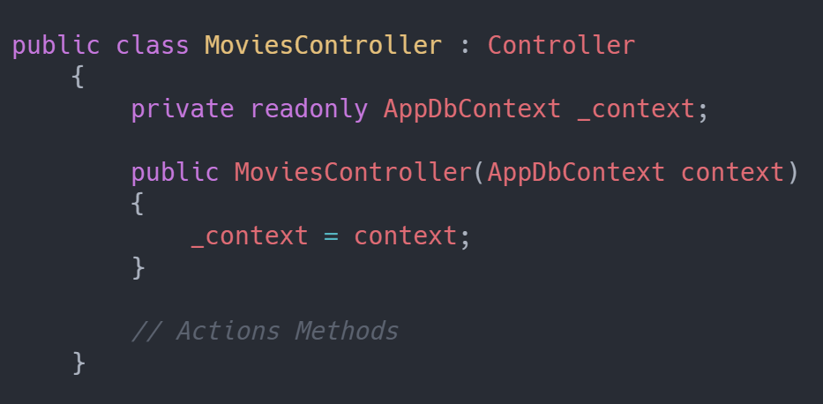

* Action method to get list of movies and Details of Movie with Id is:

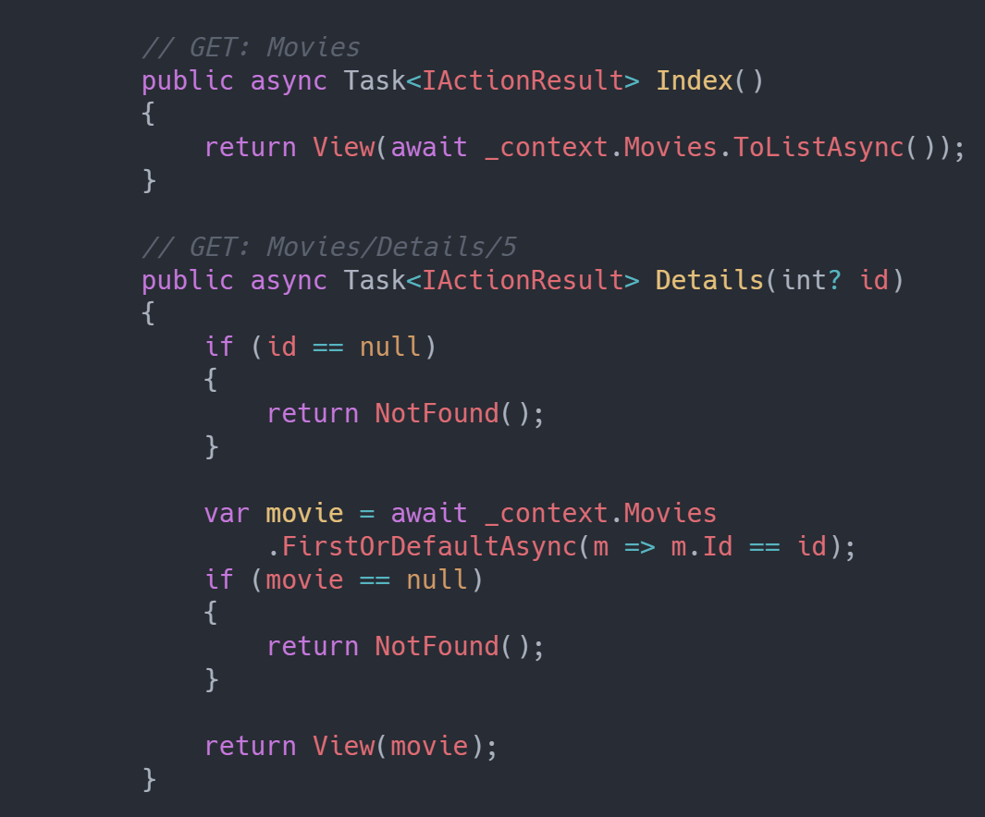

* Action method to create is:

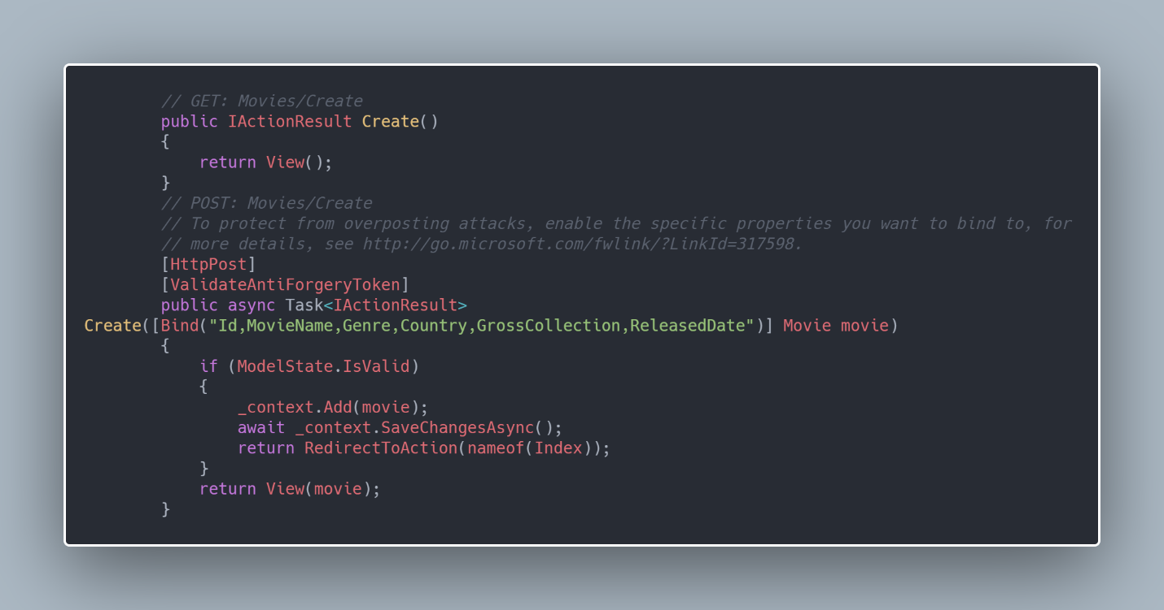

* Action method to Edit is:

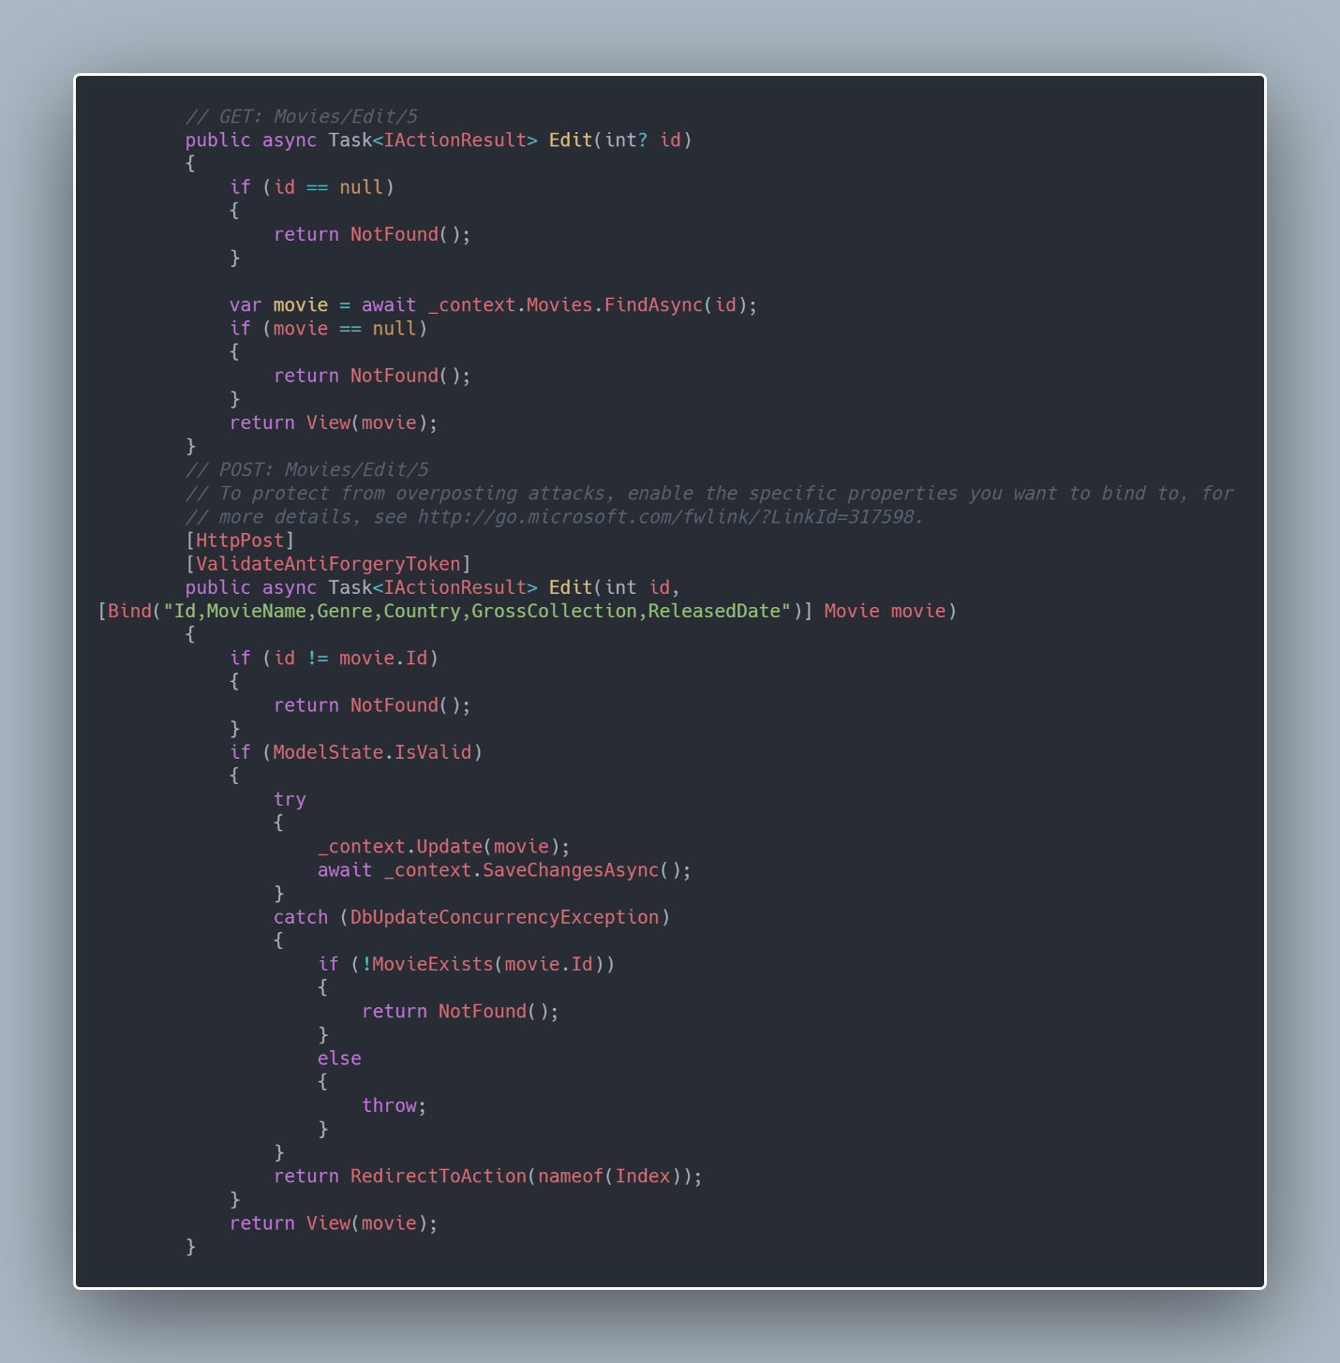

* Action method to Delete is:

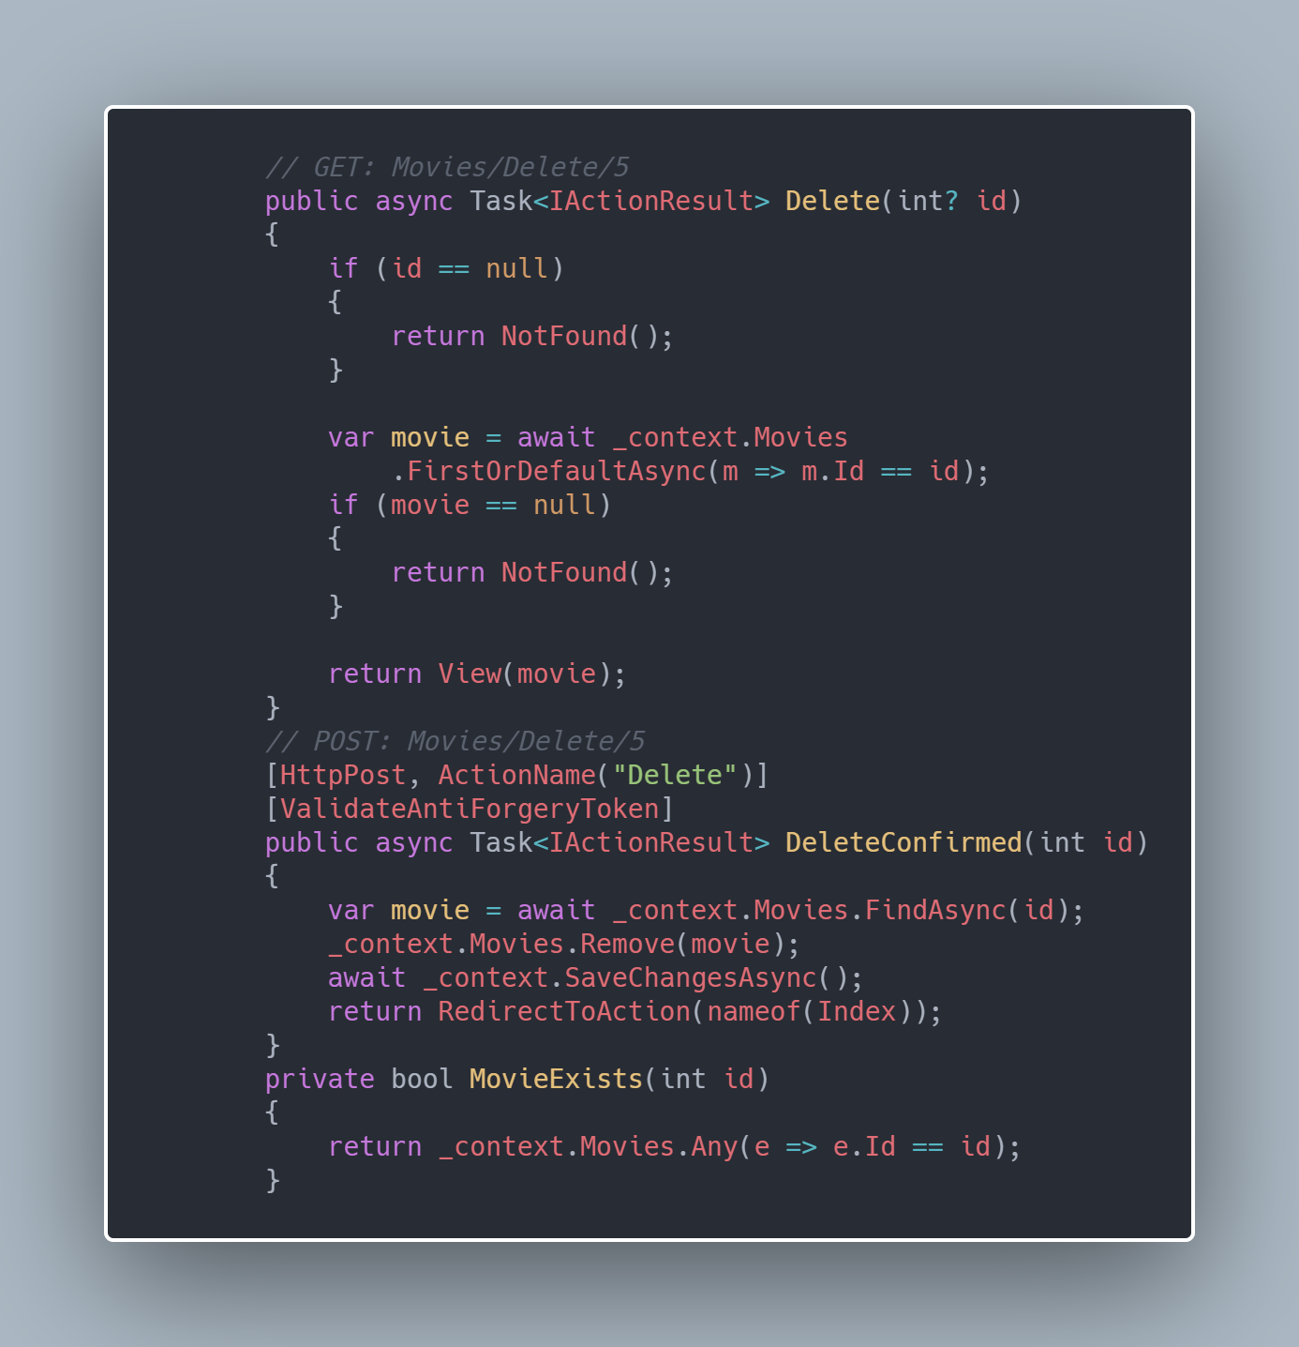

* View Page for Index:

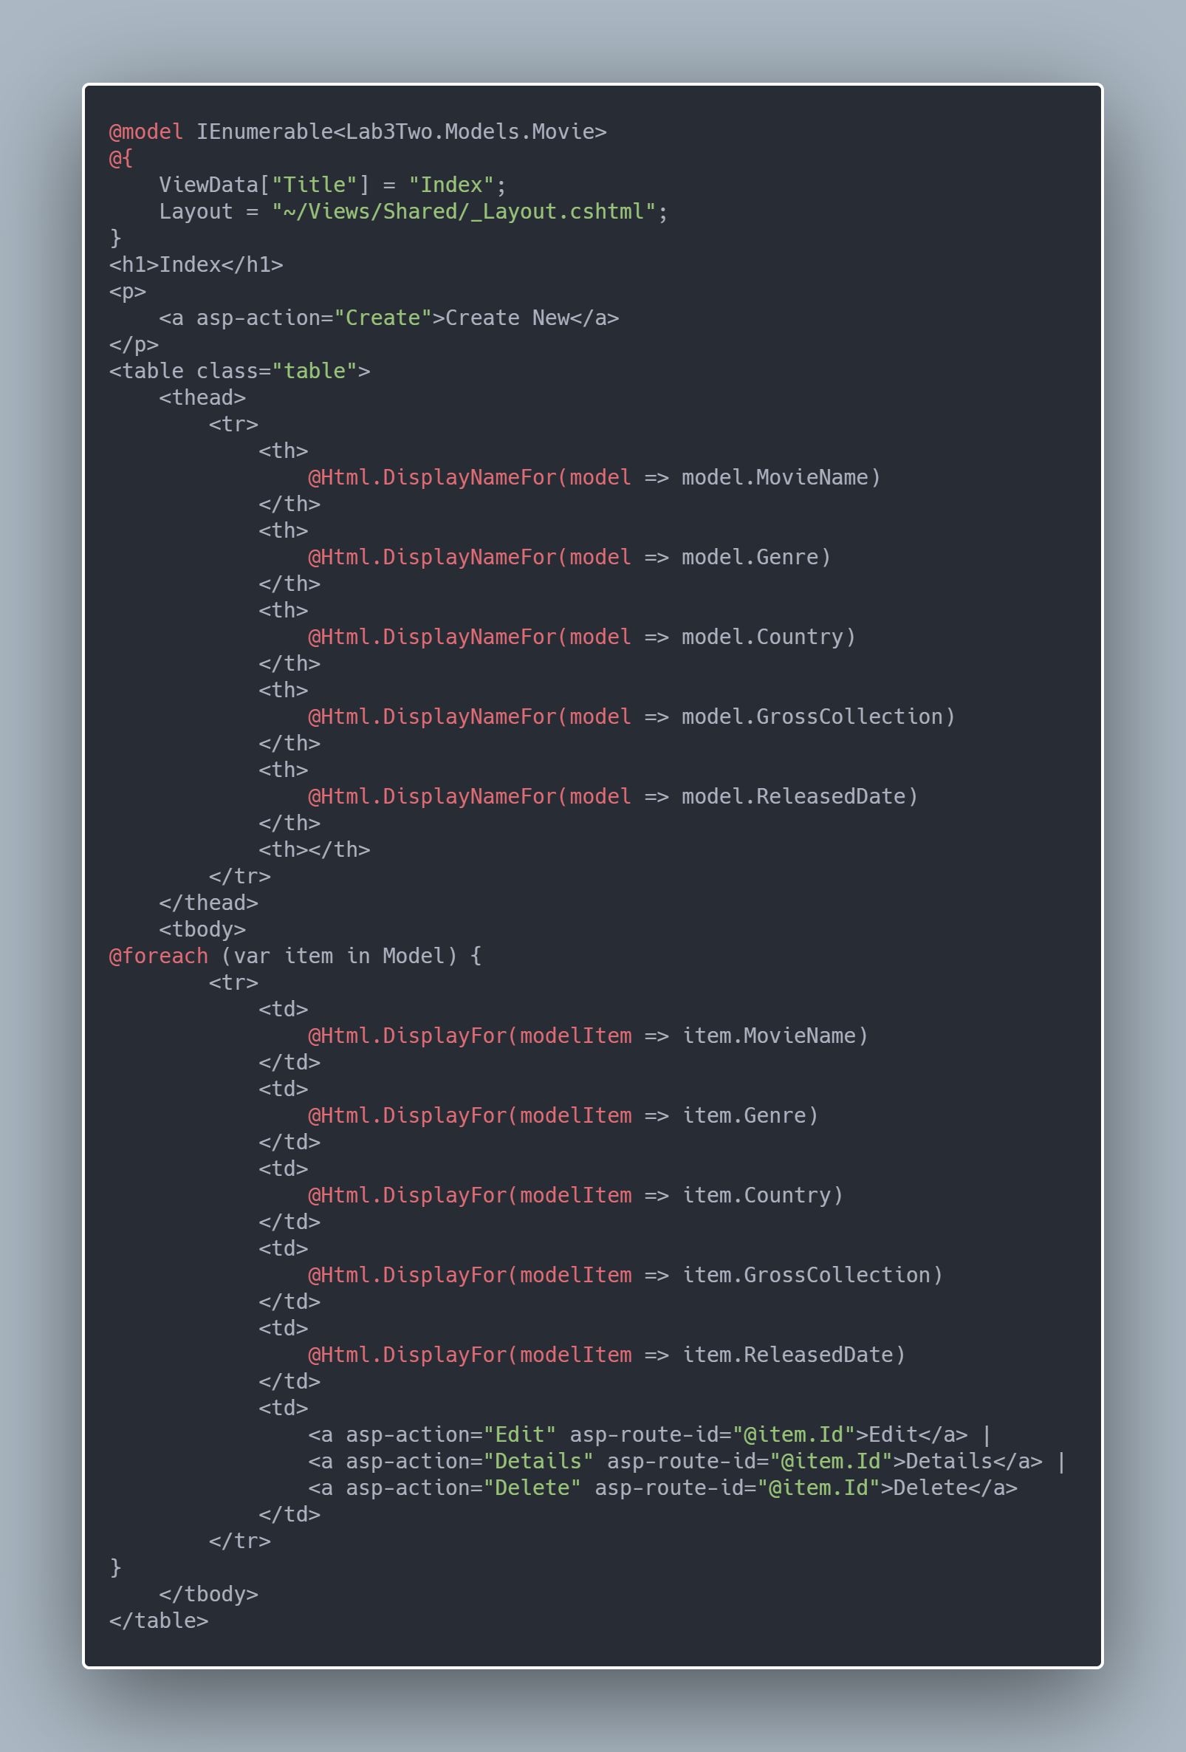

* View page for Create is:

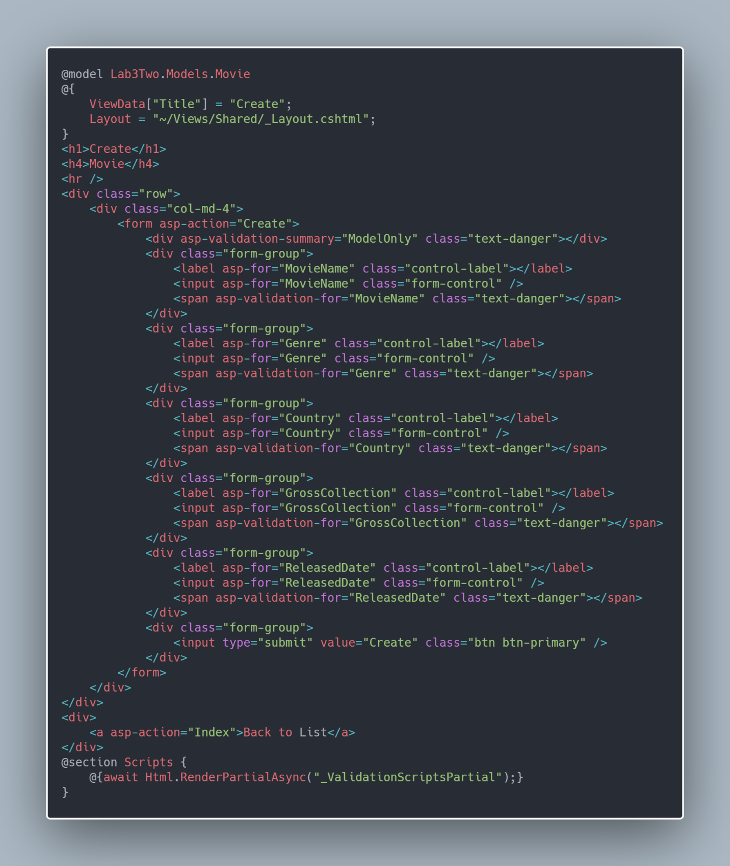

* View Page to Edit is:

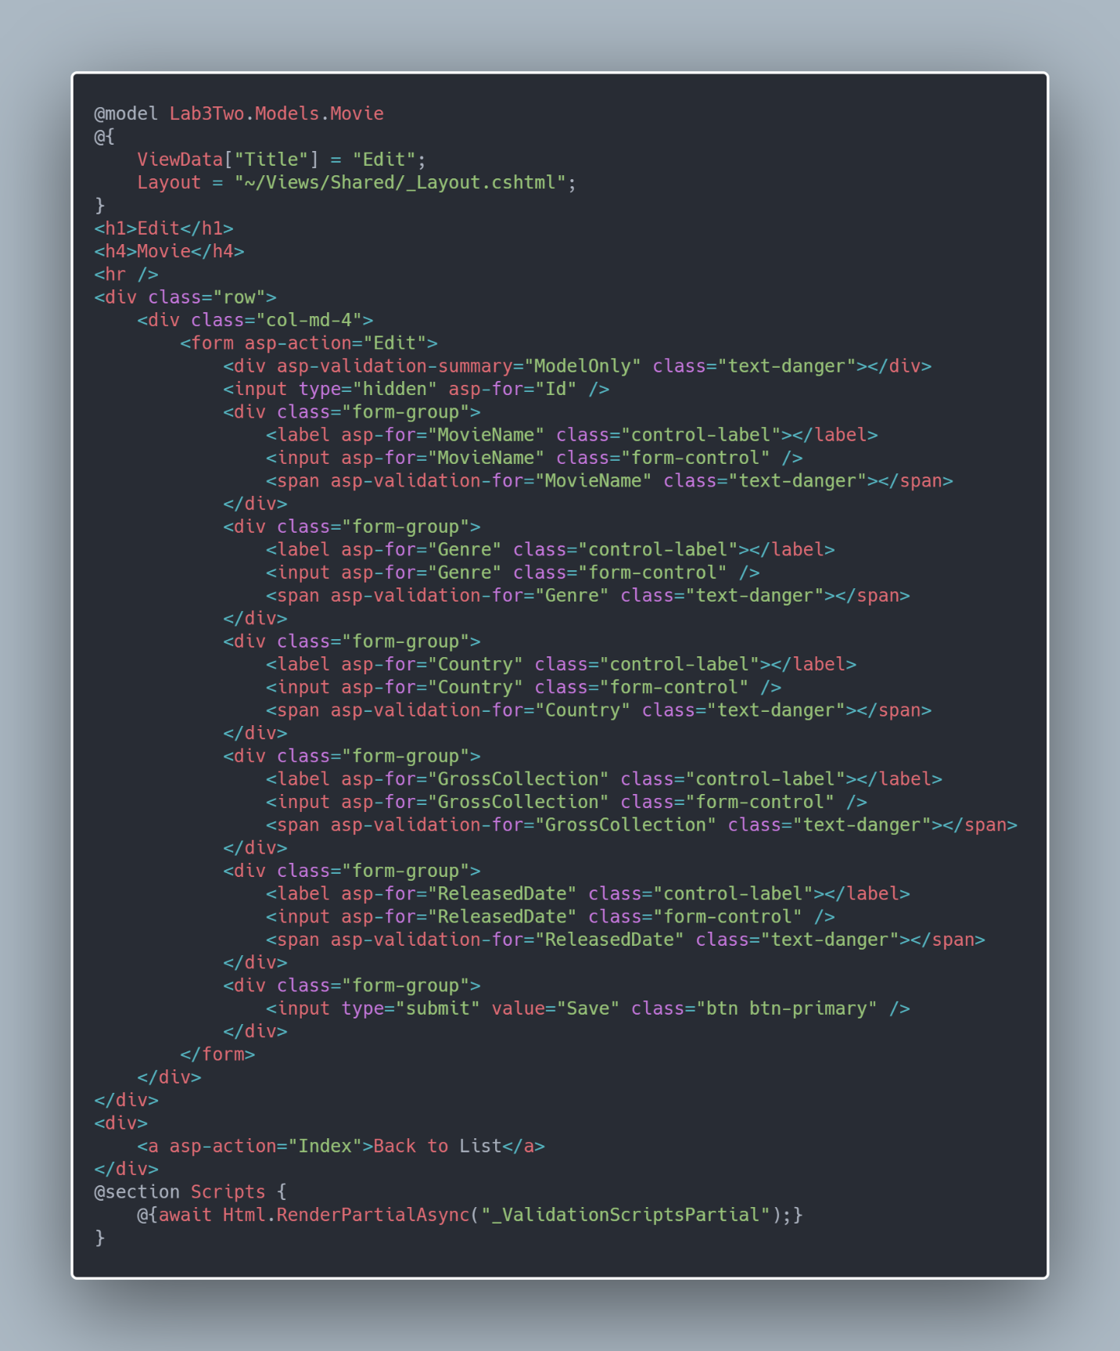

* View Page for Details is:

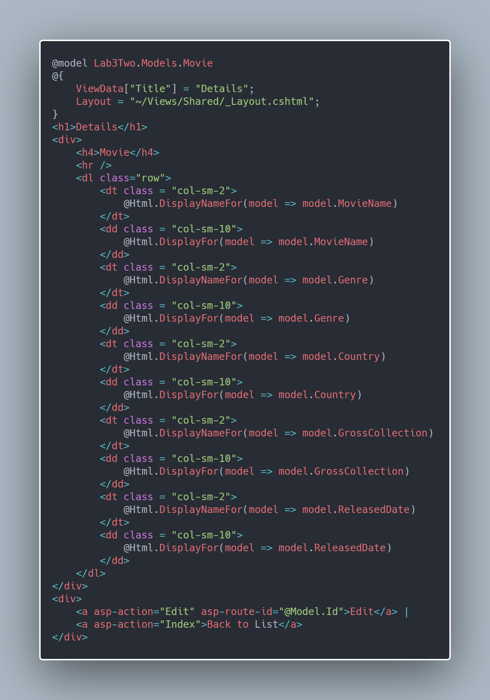

* View Page for Delete is:

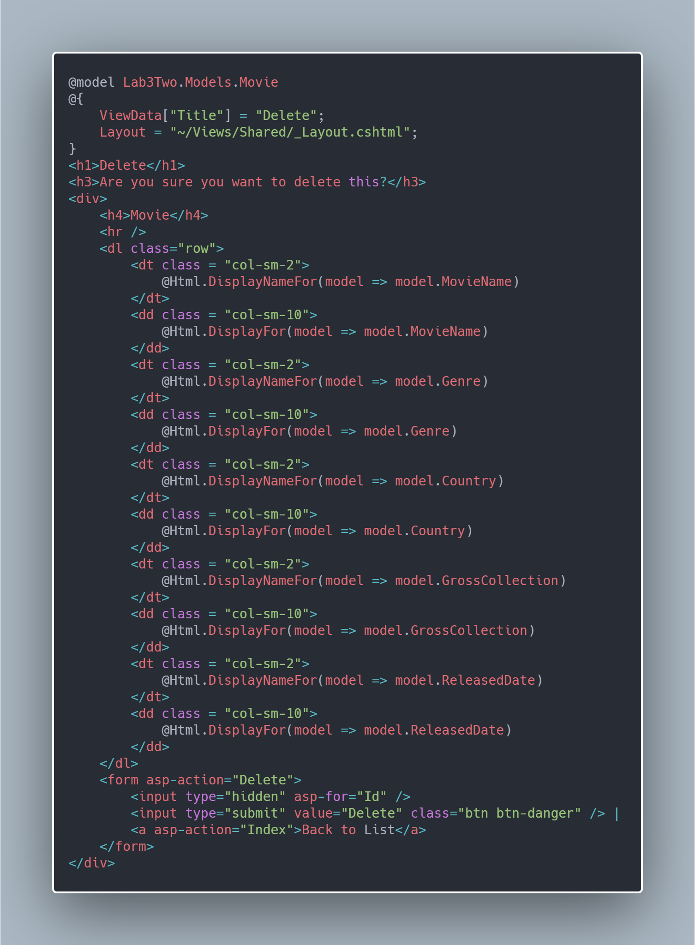

The Output is: 